# **TASK- 5**

1.Opened Wireshark.

2.Start capturing on your active network interface.

3.Browse a website or ping a server to generate traffic

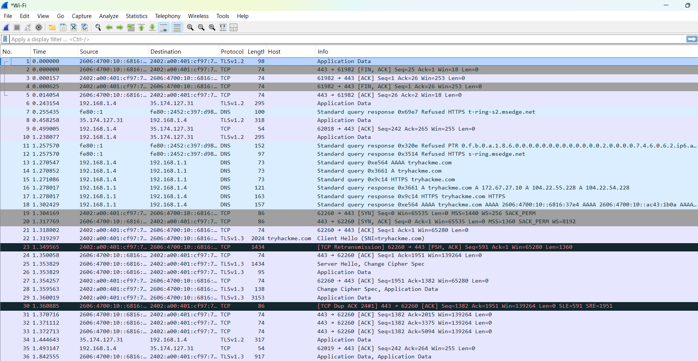

4.Filter captured packets by protocol

i - DNS

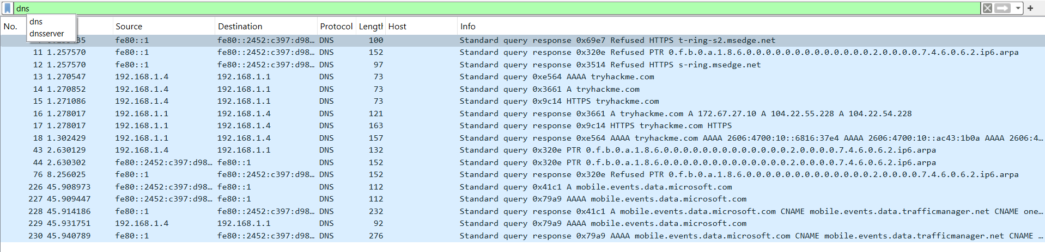

ii - TCP

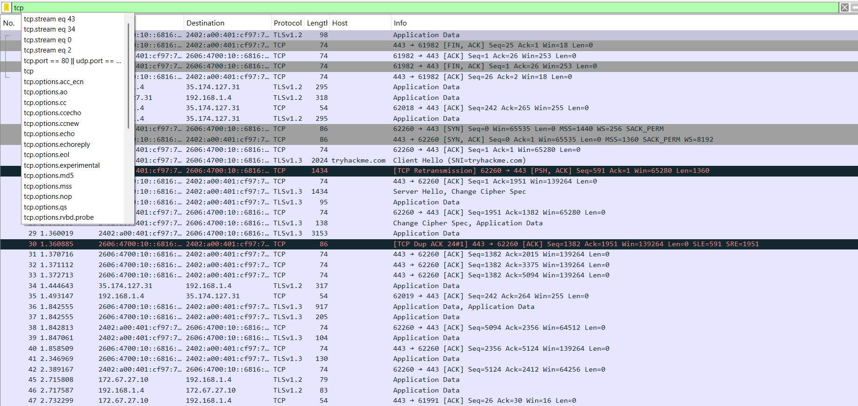

iii - UDP

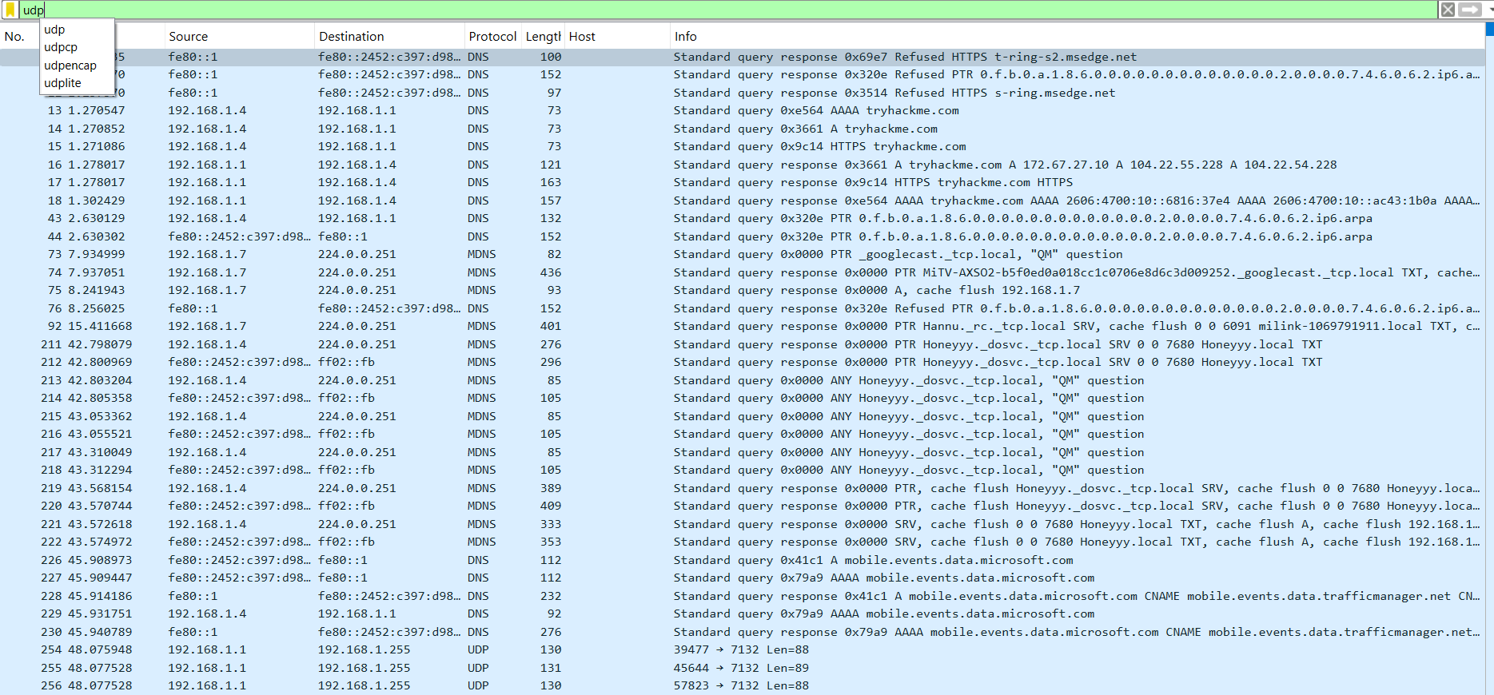

Saved the pcap file  
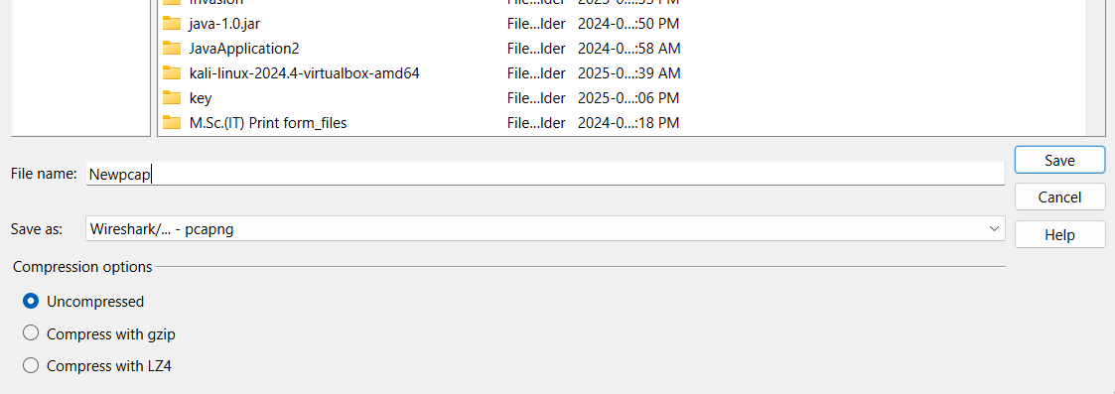

Identifying 3 protocols in the capture

TCP: Transmission Control Protocol

UDP: User Datagram Protocol

DNS: Domain Name System

Summary:

The operation of performing packet capturing task by using Wireshark tool, captured the all ongoing and outgoing traffic of the selected interface (Wifi).

All the captured packets give the protocols which are being used at the capturing time.